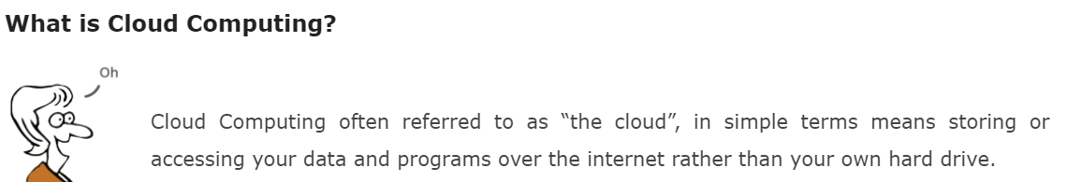

Everything nowadays is moved to the cloud, running in the cloud, accessed from the cloud or may be stored in the cloud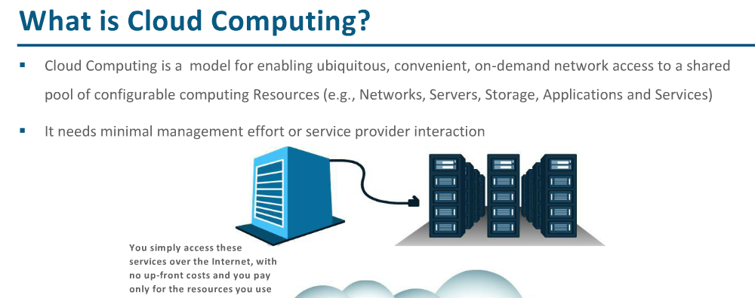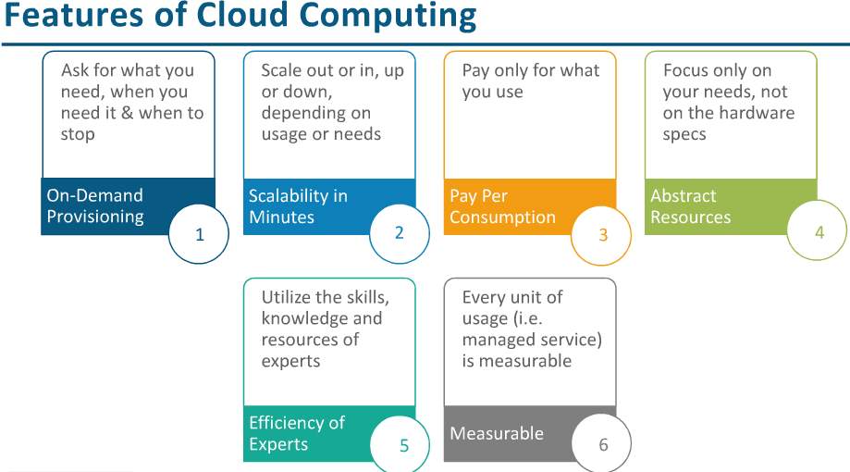

***Where exactly is this cloud?***

it is somewhere at the other end of your internet connection where you store your files and can be accessed from anywhere in the world. This could be a big deal for you, primarily because of three reasons:

* You do not have to maintain or administer any infrastructure for the same.
* It will never run out of capacity, since it is virtually infinite.
* You can access your cloud based applications from anywhere, you just need a device which can connect to the internet.
* Users can provision and release resources on-demand.
* Resources can be scaled up or down automatically, depending on the load.
* Resources are accessible over a network with proper security.
* Cloud service providers can enable a pay-as-you-go model, where customers are charged based on the type of resources and per usage.

E🡪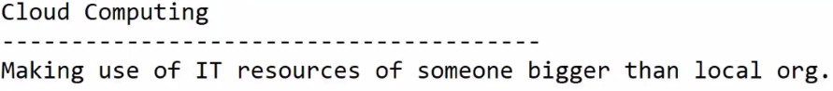

Ex: We have Uber, Cab System..Everywhereelse.

I want to go from point A to B.

Options: 1.) Buy a car and go a.) (Need big expenditure)—CAPEX

Need to take care of b.) Service

c.) Maintenance

d.) Insurance

Worry of e.) parking

f.) Wear and tear.

g.)car break down on way

More than expenditure, we must take care of all these things…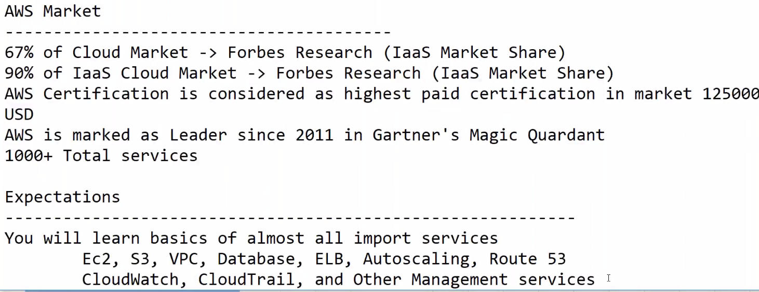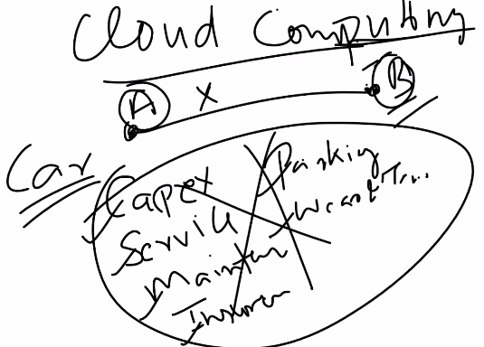

Rather, we have different choice …

2.) Take Uber cab. Only take care of a.) Fare only

No need to care of all these. We don’t need to take any responsibilities….

Now, here we can consider Uber as Cloud Computing Provider.

Uber is giving their Cars for Service. Car as Service actually correlate to Cloud Computing..

Ex-2: Dominos, McDonalds…They are not into IT and technology . Their Main job is to serve pizza.. Thats’ only thing they need to a.) Concentrate on how to make Good Pizzas only.

b.) How to improve their Product Chain.

c.) How to improve their Product line.

d.) How to give discounts, Coupons and promote their product

e.) Marketing.

To facilitate All these, they have one infrastructure in place(DataCenter inside their Corporate Office).

Inside Dc, Will be having lots of servers, racks.

So, Domios is posting their racks…Dominos need to take care of these Racks.

They need to buy these Racks.., for which again….

1. Capital Expenditure is there
2. Need to take care of service and maintenance
3. Power supply
4. Cooling System
5. Downtime….etc

BUT..HERE WE HAVE FULL CONTROL OVER INFRA(ON-PREMISE) 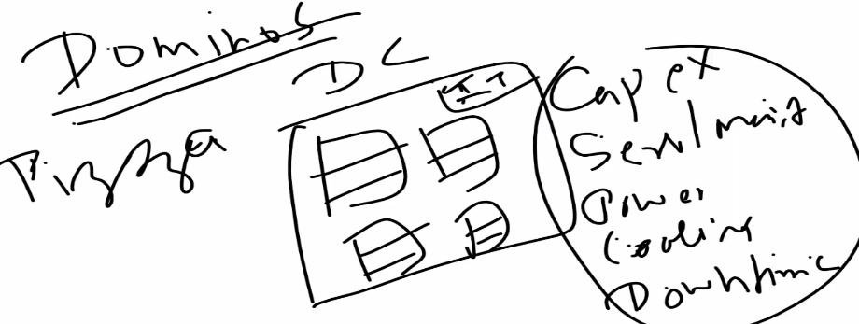

1/4 (25%) capacity would be just to facilitate Operations part (IAAC) Infrastuture Management.

**Large companies doenot want that…25% of manpower just to take care of these servers**.They want somebody else to take care of it…So Cloud is coming into picture…

This entire infra…is getting into Cloud..

Entire DC is hosting on cloud.. And will be having direct Internet access to access those servers…

Host storage, servers, N/wing devices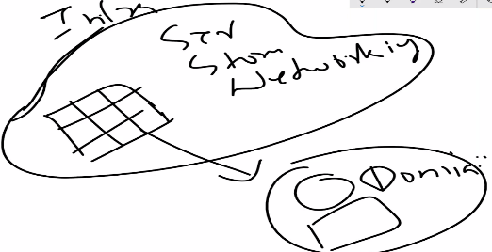

Now, Let’s see have Startups are adopting this rapidly from 2013..

Lets say there is a New startup Amazon.

Amazon is broker..A user wants to buy mobiles from Amazon, which redirects to seller who sells it..

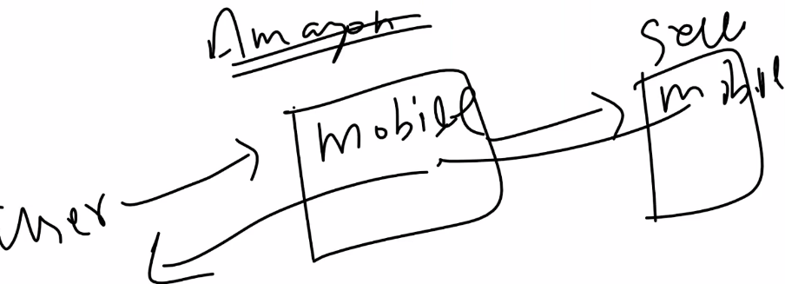

It may be mobile or food…

I want this kind of setup..If cloud is not in picture..You need to implement idea…

Order servers, where we gonna for host website.. It may take 3-6 months for servers to Arrive, and install (1 month)…Code and Host website( 6 months)…

Now, after 3 months..lets say this business is not clicking and want to Shutdown server…

---Lets say we bought 5 servers, each cost 10,000 $..So, already made commitment of 50,000 $ which is huge amount..

After 9 months, we cannot Rollback business.

Even if business is not working, we have to sustain it…

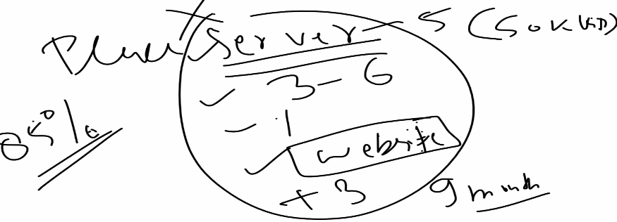

With AWS, allw e need to create is AWS account (2 min) and make server running (2min)..

Tot: 5 min.., we can get server up and running..Now, time to bring server (5 months) gone to 5 min..

After, 2 weeks if we realize server is not working…You can terminate..We will be charged Only for 2 weeks**…(Charged for what you used, and how long you used)..**

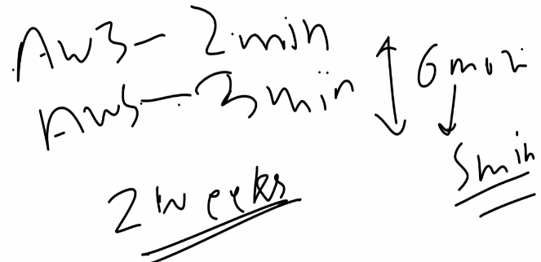 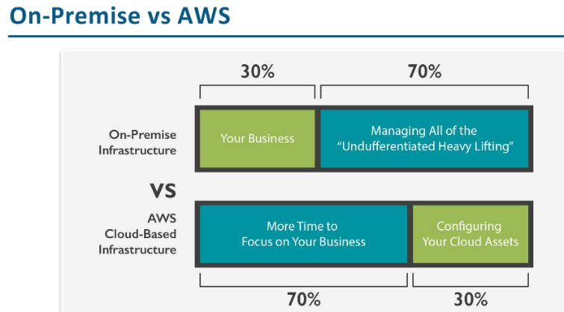

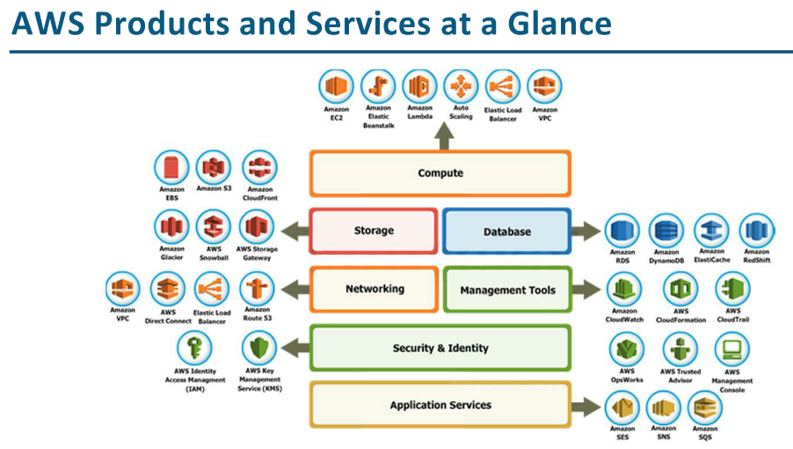

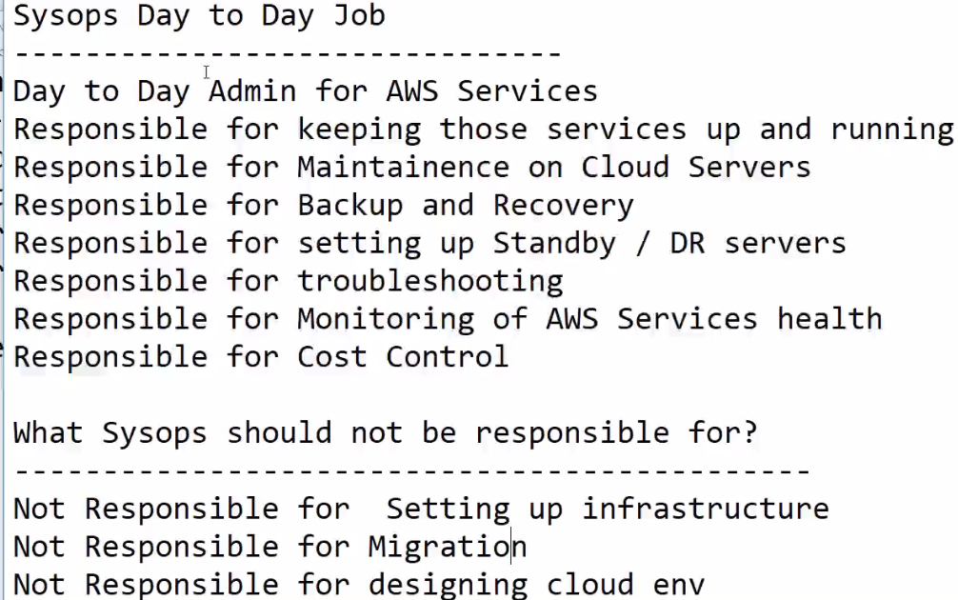

**Standby or Disaster recovery**

**Troubleshooting: Instances are slow…Going down rapidly. Long time to launch**

**Migration: Solution Architect Job..**

**We will not be doing traditional Linux/windows admin job…We will be doing Cloud Support job**

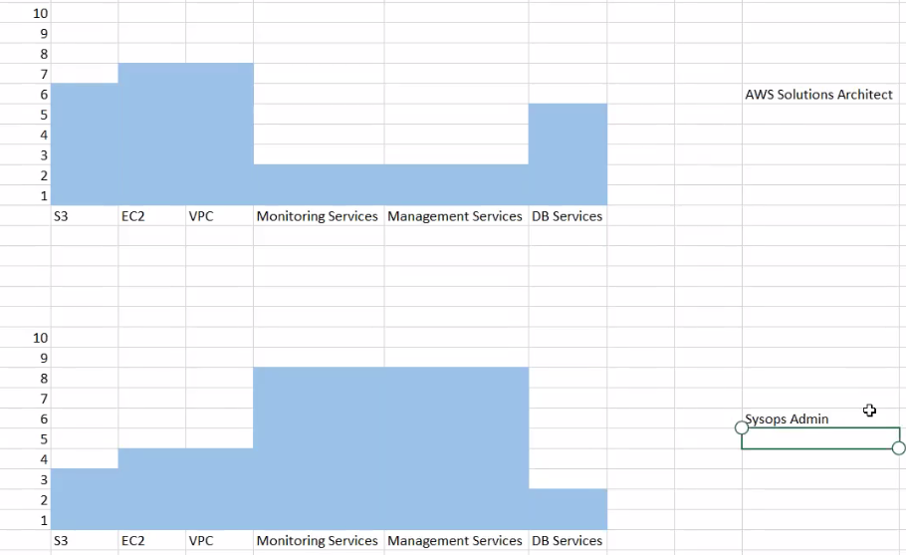

Infrastructure is available as a service from remote location.



Ex: Dropbox.. It’s as service which helps to store data over cloud..

Googledocs.. We can create ppt, doc over internet.. No need to install software..

**PAAS:**



Ex: Bhushan is java developer.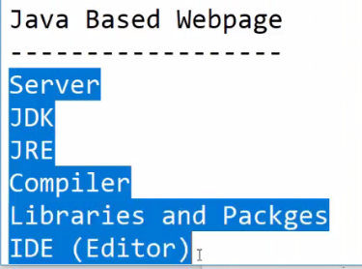

There is dependency for developer over admins to setup environment

--🡪Hosting any data/server into cloud is llike: How you take apartment or rent.

That apartment will be owned by owner…We will be staying as Teant.

There will be common service available for every one(loby/park etc..)

This owner-tenant model follows shared responsibility Model.

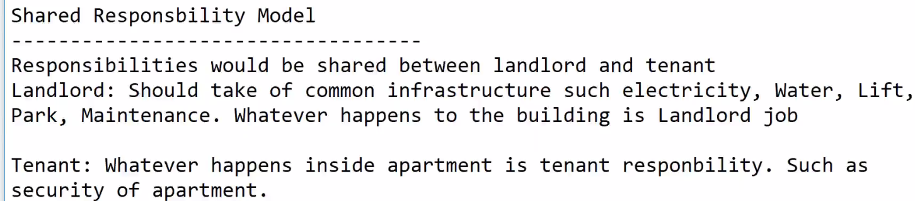If you lock door. it’s ur problem. Complain your thongs stolen.. Ur problem.

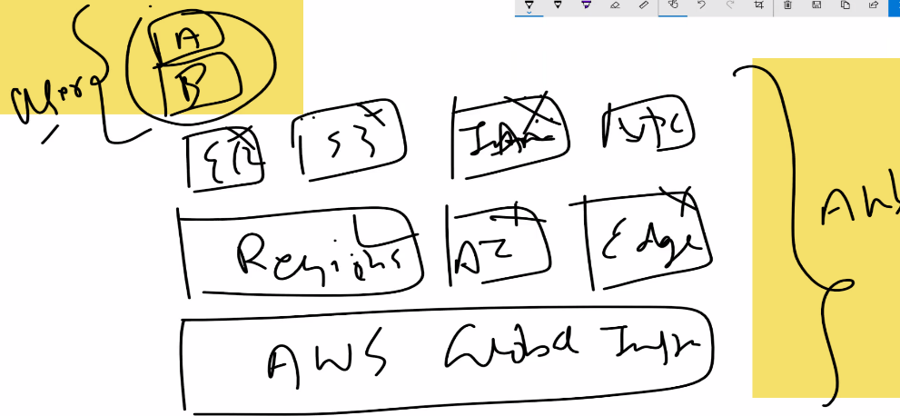

-🡪 AWS only takes care of Global infrastructure…. 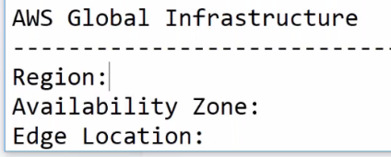

**Region:** Geographic Location where servers are located.Ex: Mumbai, Ohaio, N.Viginia..

It’s not actual place where

It is not located in complete N.Virginia..It’s not actual place where DC are..N.Virigia is a big place..It wiwll not be on complete(in and around) N.Virgina …There will be a paricular place inside where DC would be..

AZ: AZ are place inside actua region(Actual Data cennter) .In Mumbai, there are 2 AZ…Real Data Center..

**Every region must have 2 AZ..For fault tolerence..**

-🡪You try to place data across multiple AZ.If we place data on one AZ only..And it catches fire..Data is lost.

We will have another AZ from where data can be recovered from..

-🡪 N.Virgina have 6 AZ…Ohio -🡪 4 AZ

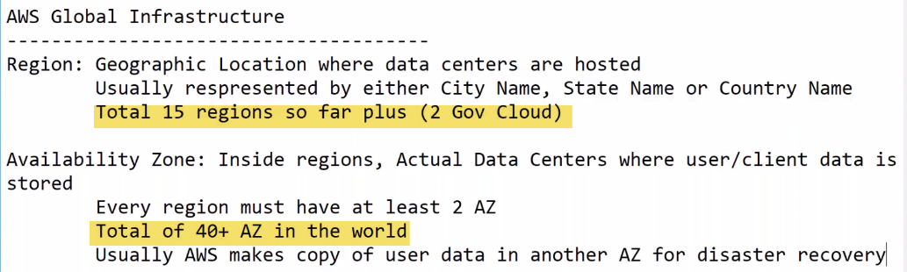

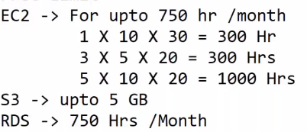

**Edge:** They are widely spread across the globe. And they are independent of regions of AZ…

Edge locations are locations of small DC throughout the world. They will cache the data..

There are about 65-70 Edge locations. 

Ex: If N.Virginia is region and there is AZ in N.Virgina where your data is.

Edge location will be throughout the world.

If India, wants to access data from N.Virgina..Data will be cached to nearest edge location so that User doesn’t need to go everytime all way to N.Virginia ..And come back for Data..



There would be much latency involved.. And speed would be faster if data is cached at nearest Edge location(Cache location) 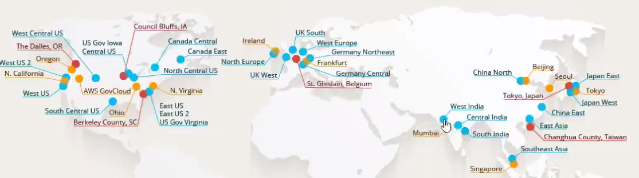

In India, there is only 1 region(Mumbai) and 3 Edge locations (West India), Central India(Delhi), South India (Chennai):

If we store some file(video file) in N.Virgina..

A user in india wants to access that file. So, what happens is every goes to Virginia and gets files back.

Since distance b/w India and V.Virgina is big.. There will be high latency(Data will come slow) issue.

It’s not a direct a Direct Lan..It will be through Hop-on hop-off through various channels under c-cable..That’s how data reaches..

And that’s how Data comes as wll..

Edge locations will be near-by.

Suppose user is in Banglore,Edge location is somewhere in Mumbai..If Edge locations are activated..

Lets user A want to search for file .Then it will go to edge location and search that file.

Since it is first request, file willnot be there..Request is made from Edge location to N.virginia and it again come back.That file A will be stored inEdge location.This file is served to User, which is faster..

If 2nd user B searches for file, it will go to Edge location and will be served back from Edge location..

This way file will be served fast using Edge lcoations. 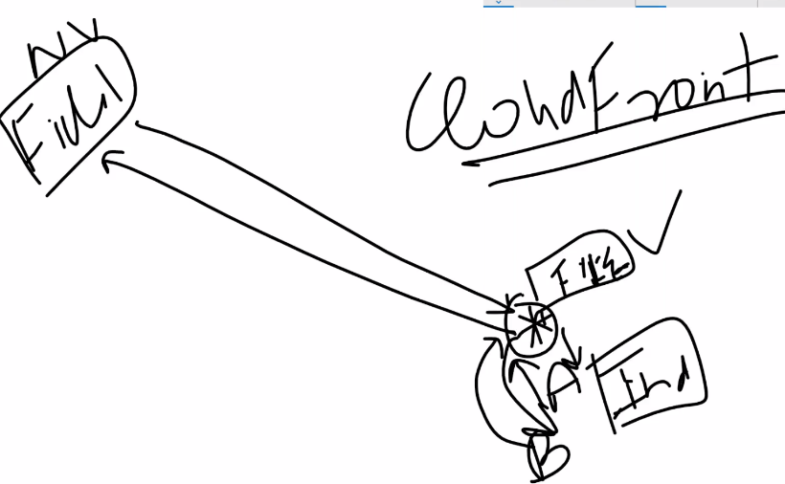

There is CloudFront, which uses Edge locations in better way...

User will not know about data served form edge locations or real(origin region) place..

Ex; If I use Amazon.in on chrome ..it will be faster if used many times. Because it will be cached..

If I use on IE first time, it will be slower... It will take to load data

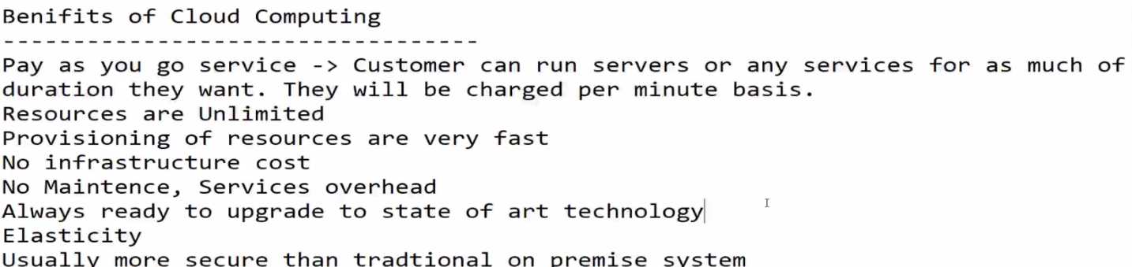

**By 2015**

**Associate: Developer, Sysops, Architect.**

Architect: Migration, design and implementation phase.

Sysops: Day to Day operations.

Devops: Automation on Cloud

**Professional: Architect, Devops**

**Hardest: Sysops associate is hardest of all. Developer associate easiest of all..**

**Now**

**They launched specialty certifications.**

Advanced Networking

Bigdata Certification

Security Certification

**8 certifications available as of now.**

If EC2 stopped, we will not be paying for Ram and CPU.. Only for storage need to pay.

